**VISVESVARAYA TECHNOLOGICAL UNIVERSITY BELGAUM, KARNATAKA**

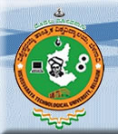

**A Mini Project Report on**

**"3D MANHATTAN BRIDGE”**

***As Per the University requirement for the VI Semester academic curriculum in Computer Science & Engineering of the Visvesvaraya Technological University, Belgaum during the year 2011-12***

**by**

**PRARTHANA S (4GW09CS035)**

**PALLAVI B (4GW09CS028)**

# Under the guidance of

**Mrs.Tejaswini R M Mrs.Usha K Patil**

**Lecturer Lecturer**

**Dept of CSE, Dept of CSE,**

**GSSSIETW, GSSSIETW,**

**Mysore. Mysore.**

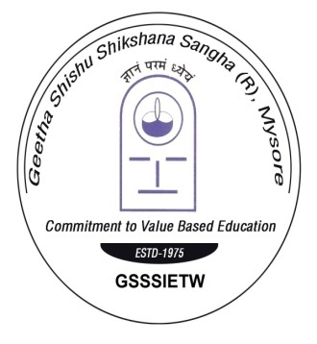

DEPARTMENT OF COMPUTER SCIENCE & ENGINEERING

**GSSS Institute of Engineering & Technology for Women**

**KRS ROAD, Metagalli, Mysore-16**

**GSSS INSTITUTE OF ENGINEERING AND TECHNOLOGY FOR WOMEN**

**K.R.S. ROAD, METAGALLI, MYSORE-570016**

DEPARTMENT OF COMPUTER SCIENCE & ENGINEERING

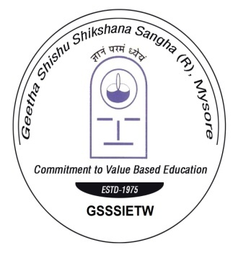

## CERTIFICATE

*Certified that the project work entitled* ***“3D Manhattan Bridge”*** *is a bonafide work carried out by* ***Prarthana S (4GW09CS035), Pallavi B (4GW09CS028)*** *during the year 2012 as per the University requirement for the VI semester academic curriculum. The Project report has been approved as it satisfies the requirements with respect to the project work prescribed for Bachelor of Engineering degree.*

Signature of the Guide Signature of the Guide Signature of the HOD

**Mrs.Tejaswini R M Mrs.Usha K Patil Mrs.Radha Sudarshan**

Lecturer Lecturer Associate Professor

Dept of CSE Dept of CSE Head, Dept of CSE

GSSSIETW GSSSIETW, GSSSIETW,

Mysore. Mysore. Mysore.

**Examiners**

Internal External

Name ________________ ______________

Signature ________________ ______________